**Level 1: PC Tower Case**

**Outline**

Learn about the internals of a standard PC case by examining physical samples and selecting and labeling images found on-line. Gain deeper knowledge by researching and reporting on specific components.

**Questions**

1. Find one (or more) images that clearly show the internals of a PC Tower Case.   
   (i.e. Google images using keywords “PC Case Internals”)

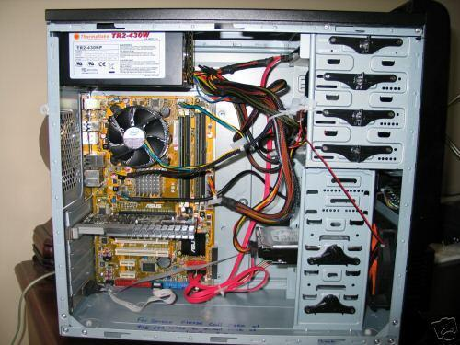

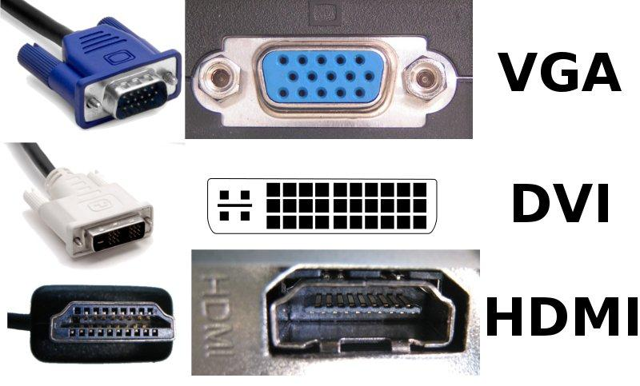 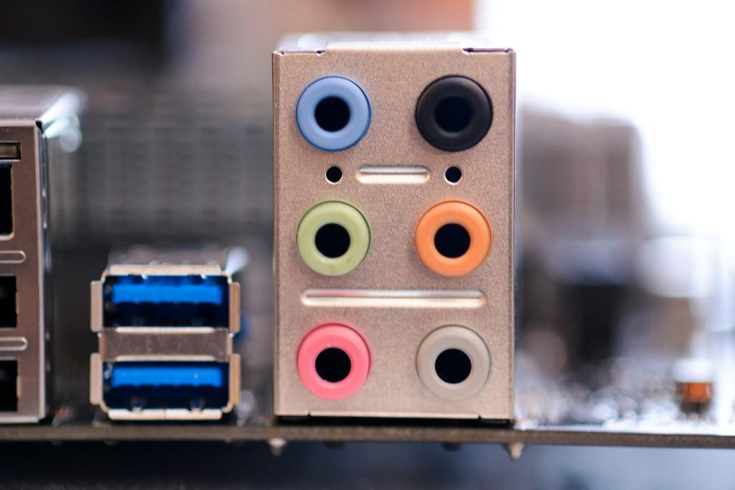

**Monitor Ports Audio Ports**

1. Clearly label the following components (using arrows) on your image of the PC case internals:
   1. Motherboard
   2. Power Supply
   3. Hard Disk Drive
   4. Optical Disk Drive (e.g.DVD)
   5. USB Expansion Ports
   6. Monitor Port
   7. Audio Ports
   8. Ethernet Port
   9. Cooling Fan
2. Research more in-depth about “Motherboards”. Make notes on the following:
   1. What different versions are currently available (speed and capacity)

* ATX Motherboard:
  + Has dual channel of 2133 MHz DDR4 up to 128GB
* LPX Motherboard:
  + 4*8GB (32GB) [Each quartet RAM memory is 8GB]
  + A speed of 4333 MHz
* BTX Motherboard:
  + A speed of 1066MHz
  + Supported capacity of 8GB
* Mini ITX Motherboard:
  + Supported capacity of 32GB
  1. How the component has changed since the 1980’s
* Compared to the components from the 1980’s, the current components are much faster, have the ability to support other factors such as latest intel's/processors or have slots that can install other specific cards.

1. Research more in-depth about “Hard Disk Drives”. Make notes on the following:
   1. What different versions are currently available (speed and capacity)

* Serial ATA Storage Drives
  + 500GB and 7200RPM
* Small computer system interface
  + 36GB and 10000RPM
* Solid State Drives
  + 400GB
  1. How the component has changed since the 1980’s
* They are faster, consume less power, are very reliable, and durable.

**NOTE:**

* Download the on-line version of this module (from the class GitHub repository)
* Questions for Level 2 and Level 3 are in the on-line version of this module
* Provide your answers in a MS Word, PowerPoint, or equivalent format
* Upload your answers to your personal GitHub repository

**Level 2: PC Motherboard**

**Outline**

Learn about the structure of a standard PC motherboard by examining physical samples and selecting and labeling images found on-line. Gain deeper knowledge by researching and reporting on specific components.

**Questions**

1. Find one (or more) images that clearly show the layout of a PC Motherboard.   
   (i.e. Google images using keywords “PC Motherboard”)

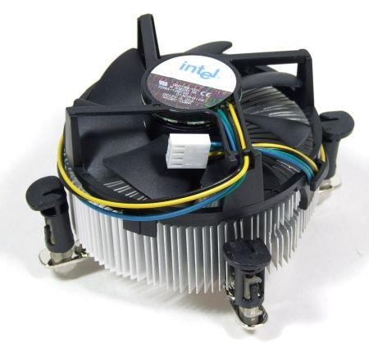 **CPU FAN 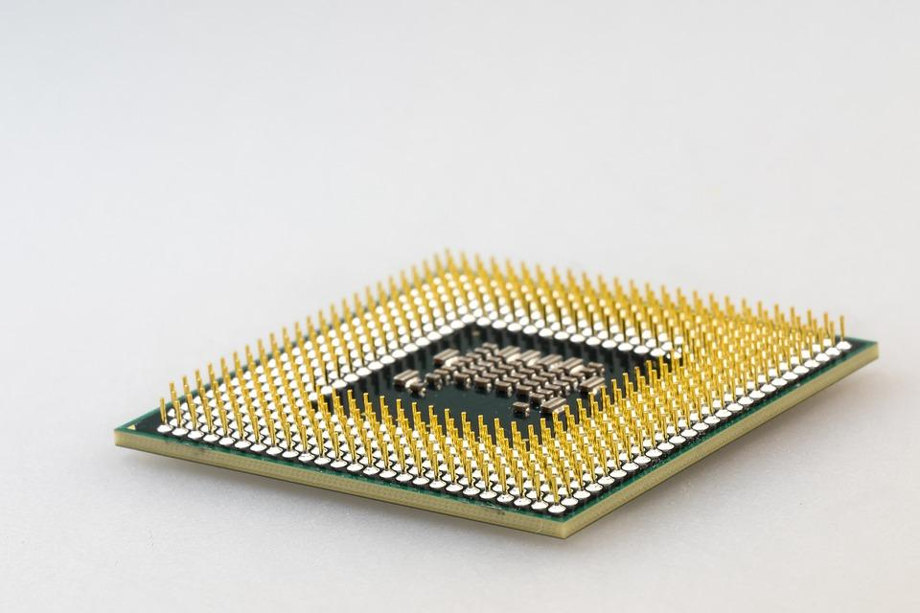 CPU Chip**

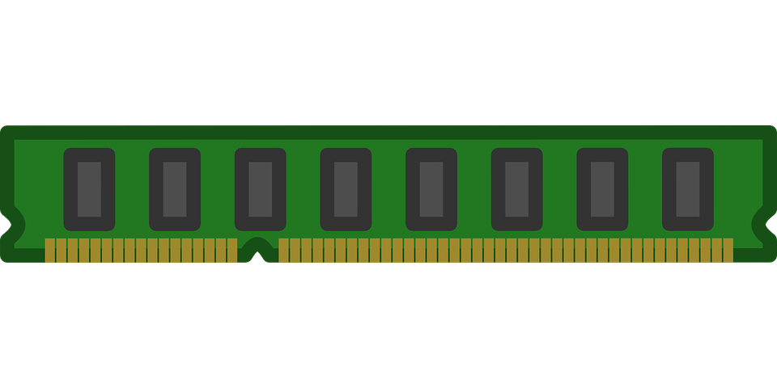 **RAM Memory 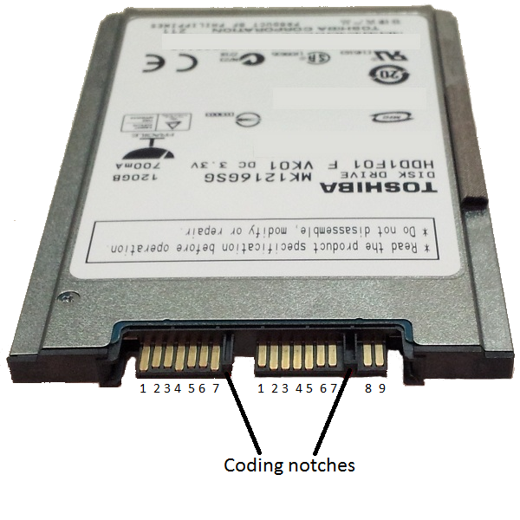 Disk Drive Interface (SATA)**

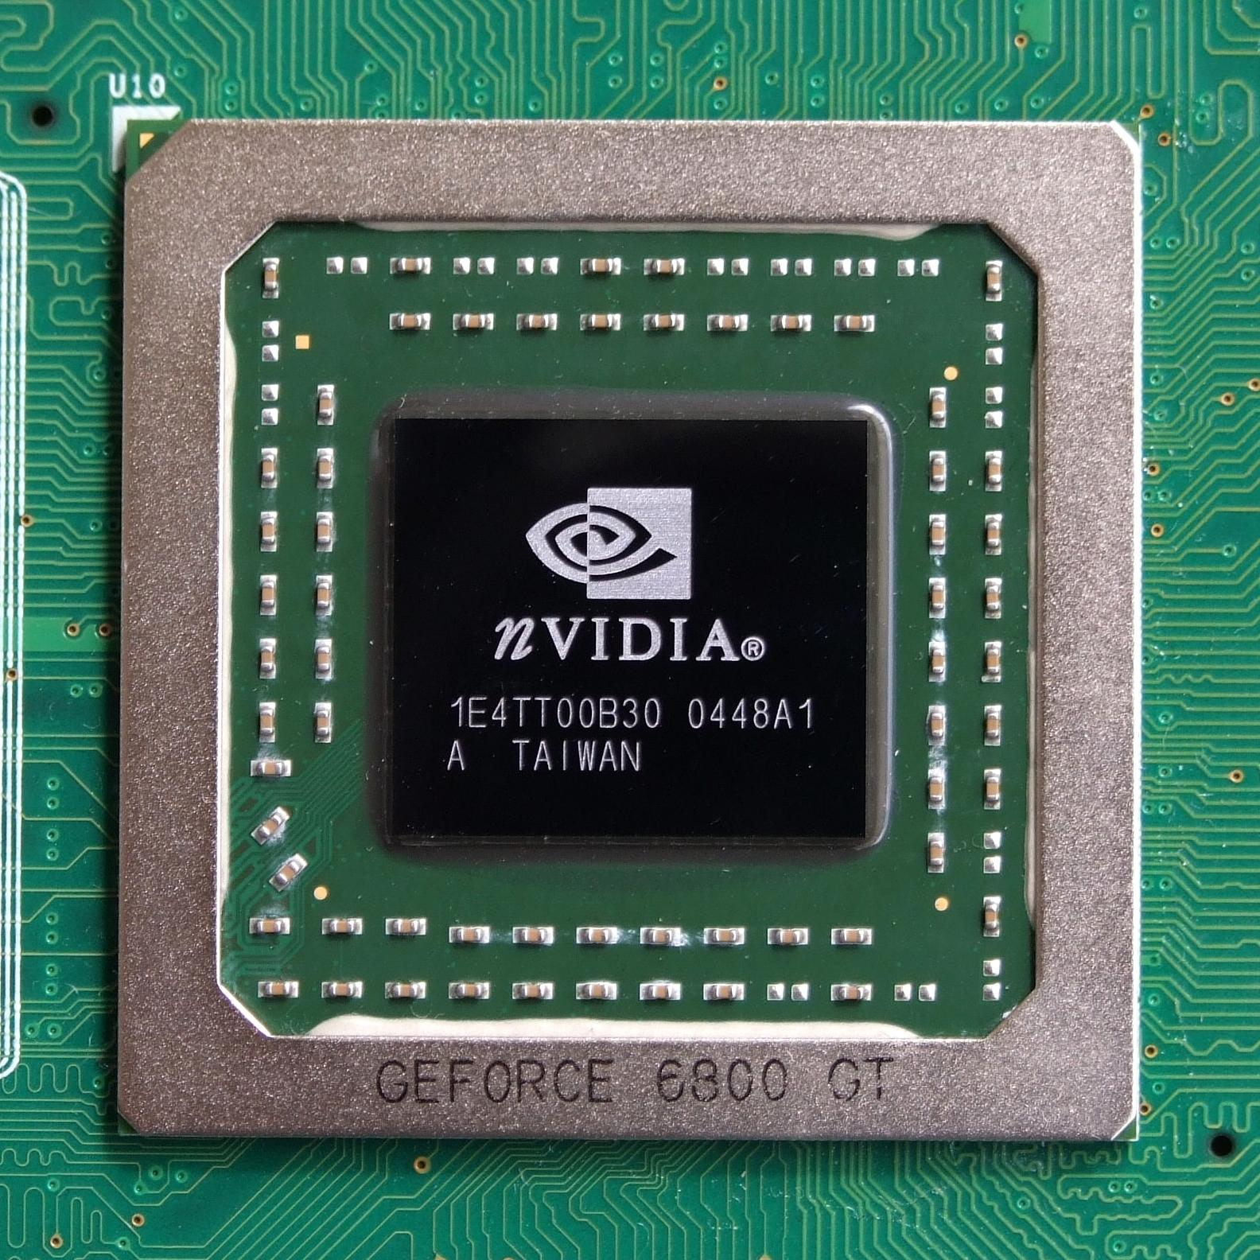 **GPU Graphics Processor 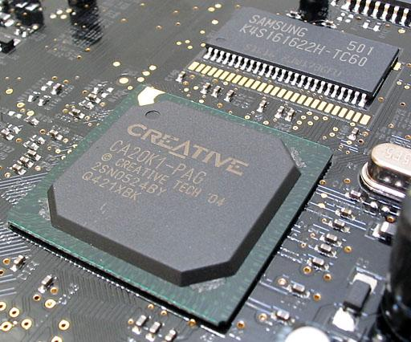Sound Processor**

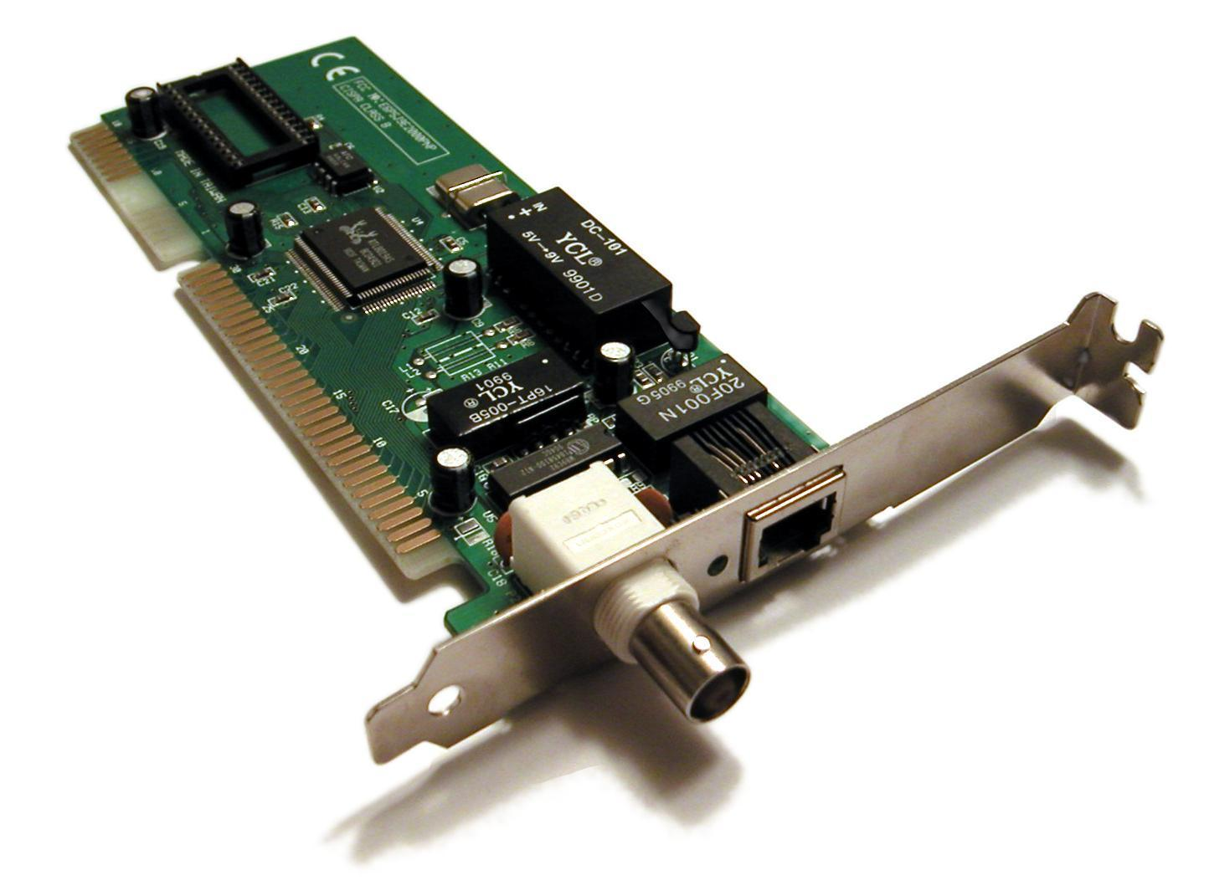**Ethernet Network Interface**

1. Clearly label the following components (using arrows) on your image of the PC motherboard:
   1. CPU (and fan)
   2. RAM Memory
   3. Disk Drive Interface (IDE or SATA)
   4. GPU Graphics Processor (either on-board or Graphics Card)
   5. Sound Processor (either on-board or Sound Card)
   6. Wi-Fi / Ethernet Network Interface (either on-board or Graphics Card)

1. Research more in-depth about “CPU Processor Chip”. Make notes on the following:
   1. What different versions are currently available (speed and capacity)

* AMD Sempron - Speed: 1.0 GHz to 2.9 GHz, Capacity: varies
* AMD Athlon 64 X2 Dual-Core - Speed: 1.9 GHz to 3.2 GHz, Capacity: varies
* AMD Athlon 64 - Speed: 1.0 GHz to 3.2 GHz, Capacity: varies
* AMD Opteron - Speed: 1.4 GHz to 3.5 GHz, Capacity: varies
* Intel Celeron D - Speed: 266 MHz to 3.6 GHz, Capacity: varies
* Intel Pentium 4 - Speed: 1.3 GHz to 3.8 GHz, Capacity: varies
* Intel Pentium D - Speed: 2.66 GHz to 3.73 GHz, Capacity: varies
* Intel Pentium 3 (Pentium III) - Speed: 450 MHz to 1.4 GHz, Capacity: varies
  1. How the component has changed since the 1980’s
* 1998: Intel Celeron D - larger integrated L2 cache, faster processor system bus
* 1999: Intel Pentium 3 - extremely fast transfer of data, improved multimedia and 3D performance
* 2000: Intel Pentium 4 - desktop PCs and entry-level workstations, improved performance, used mostly in multimedia, updated versions: flexibility for future applications, better system responsiveness, multi-tasking, increased L2 cache and clock speeds
* 2003: AMD Opteron - offer simultaneous 32- and 64-bit computing, offer simplified migration path to 64-bit computing
* 2003: AMD Athlon 64 - doubles number of processor registers, increases system memory addressability
* 2004: AMD Sempron - needs of home and business PC users
* 2005: AMD Athlon 64 X2 Dual-Core - makes 32- and 64-bit applications run virtually simultaneously and transparently on the same platform
* 2005: Intel Pentium D - more power when running multiple applications

1. Research more in-depth about “RAM Memory”. Make notes on the following:
   1. What different versions are currently available (speed and capacity)

* Static RAM (SRAM) - Speed: Varies, Capacity: 10 KB to 10 MB
* Dynamic RAM (DRAM) - Speed: 2400 MHz, Capacity: 8Gb
* Synchronous Dynamic RAM (SDRAM) - Speed: 3200MHz, Capacity: 16Gb
* Single Data Rate Synchronous Dynamic RAM (SDR SDRAM) - Speed: 133MHz , Capacity: 64MB
* Double Data Rate Synchronous Dynamic RAM (DDR SDRAM, DDR2, DDR3, DDR4) - Speed: 3200MHz, Capacity:2GB
* Graphics Double Data Rate Synchronous Dynamic RAM (GDDR SDRAM, GDDR2, GDDR3, GDDR4, GDDR5) - Speed: 7GHz, Capacity: 6GB
* Flash Memory - Speed: Varies , Capacity: 8GB to 256GB

**The speed and capacity of RAM Memory varies.**

* 1. How the component has changed since the 1980’s
* 1970’s: DRAM - lower costs of manufacturing, greater memory capacities, slower access speeds, higher power consumption
* 1984: Flash Memory - retains all data after power is cut off
* 1990’s: SRAM - lower power consumption, faster access speeds, lesser memory capacities, higher costs of manufacturing
* 1993: SDRAM/SDR SDRAM - process overlapping instructions in parallel
* 2000: DDR SDRAM - lower standard voltage, prevents backwards compatibility, updated versions: improved performance, advanced signal processing (reliability), greater memory capacity, lower power consumption, higher standard clock speeds
* 2003: GDDR SDRAM - improved performance, lowered power consumption

**Level 3: Peripheral Devices**

**Outline**

Learn about how peripheral devices are connected to the back side of a typical PC tower case. Examine physical samples, select and labeling images found on-line and gain deeper knowledge by researching and reporting on specific components.

**Questions**

1. Find one (or more) images that clearly show the layout of the back of a typical PC tower case.   
   (i.e. Google images using keywords “Back Of PC Tower”)

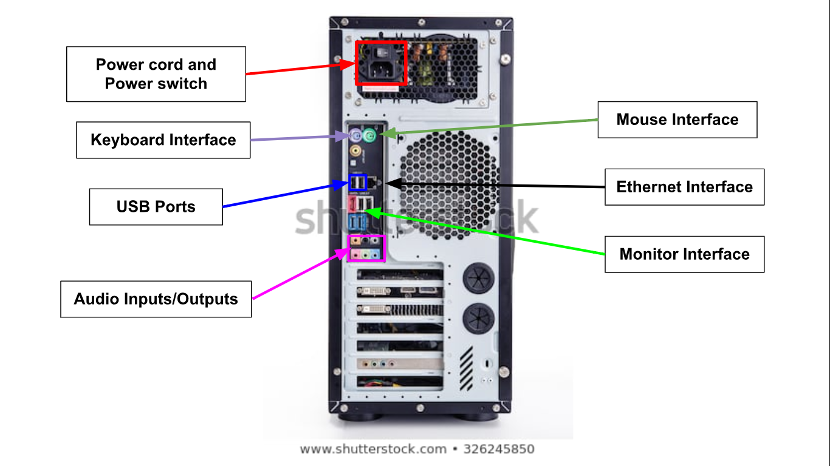

1. Clearly label the following components (using arrows) on your image of the back of a typical PC tower case:
   1. Power cord and power switch
   2. Monitor Interface (VGA or DVI or HDMI)
   3. Mouse Interface (USB or PS/2)
   4. Keyboard Interface (USB or PS/2)
   5. USB Ports
   6. Audio Inputs / Outputs
   7. Ethernet Interface

1. Research more in-depth about “Monitor Technology”. Make notes on the following:
   1. What different versions are currently available (e.g. VGA / DVI, Flat Panel Technology)

* VGA (Video Graphics Array)
  + lower resolutions
  + lower quality display on screen
* DVI (Digital Visual Interface)
  + Reduce overall power consumption
  + Compatible with HDMI
  + Does not support audio data directly
* HDMI (High Definition Multimedia Interfaces)
  + Transmit audio and video data with one cable
  + Less vulnerable to interference and signal noise
  + Best quality picture and sound
* Flat Panel Technology
  + Monitor, television
  + Use thin panel design
  + Thinner and lighter screen
  + More portable
  + High resolution
  + Use a liquid crystal display
  1. How the component has changed since the 1980’s (e.g. Display Resolution, Technology)

1. Research more in-depth about “External Portable Storage”. Make notes on the following:
   1. Floppy Disks

* Portable
* Slower to access than disk drives
* Less capacity and less expensive
  1. CD-ROM / DVD / Recordable CD/DVD
* Store large storage software application
* Permanently stores data that cannot be changed, written over or erased
  1. USB Memory Drives
* Used for data storage
* Small, reliable and durable
* Removable and rewritable
* The larger its storage, the faster it operates
  1. Compact Flash Memory
* Small storage
* Nonvolatile semiconductor memory
* Store data on portable or remote computing devices
* Data stored could be text, images, videos, and audio.
  1. Cloud Based Storage
* Data stored on remote servers accessed from internet
* Operates through web-based application programming interface

**Level 4: PC Component Presentation**

**Outline**

Explore the development and features of a specific PC hardware component through deeper research and investigation. Work in partners to create a short presentation. Deliver the presentation to the class.

Each group will research a unique PC hardware component . Your specific topic will be assigned from the list provided below.

**Presentation Structure**

1. Explain what the PC component does and how it fits together with other components to make up a fully functioning PC.
2. Explain how the PC component works. Provide a diagram (image) showing the main parts of the component.
3. Research the current state of the art of the component in terms speed, capacity (size), and other related factors.
4. Research on-line suppliers that sell the PC Component. List the specifications for the available products and the cost (price).
5. Research how the PC component has changed and evolved since the early days of PCs in the 1980’s. Cover each of the following topics separately:
   1. Component Speed
   2. Component Size / Capacity
   3. Two other specifications specific to the PC component (ask Mr. Nestor)

**PC Component Topics**

|  |  |  |
| --- | --- | --- |
| **Topic** | **Partner 1** | **Partner 2** |
| CPU Microprocessor Chip |  |  |
| Motherboard Layout |  |  |
| Computer Graphics |  |  |
| Sound & Audio |  |  |
| Hard Disk Drives |  |  |
| Removable Disk Storage |  |  |
| Network / Internet Connectivity |  |  |
| Mouse / Pointing Devices |  |  |
| Monitor & Display Technology |  |  |
| Printers & Output Technology |  |  |